<Book My Flight>
<Air-Ticket Reservation System>
Application Design
<Version No.0 01>



 | Prepared By | Reviewed by | Approved By
Name
Role |  | Project Leader | Project Manager
Signature
Date

Table of Contents
1.0 Introduction 3
1.1 Purpose of this document 3
1.2 Scope 3
1.3 Intended Audience 3
1.4 Definition & Acronyms 3
1.5 References 3
2.0 Conventions and Standards Followed 4
3.0 Assumptions, Dependencies and Risks 5
4.0 Use Case Realization 6
4.1 Flow of Events – Design 6
4.2 Derived Requirements 7
5.0 Package & Sub-system Design 8
5.1 Package Design 8
5.1.1 Packages 1…N 8
5.2 Sub-system Design 9
6.0 Generic Components Design 10
7.0 Object Model 11
7.1 System Object Model 11
7.2 Object Descriptions 11
7.2.1 Object <Name> 11
8.0 Database Design 12
8.1 Data Model 12
8.1.1 Identification of Tables 12
8.1.2 Table Details 12
8.1.3 Referential Integrity Constraints 12
8.1.4 Computations/processing in Database 12
8.1.5 Access Control Details 12
8.2 Storage Characteristics 13
8.3 Database Performance Improvement Measures 13
9.0 References 13
10.0 Change Log 14

Introduction

Purpose of this document
The detailed design contains the design of every module / sub-system. This covers the following:
- Design of common / generic components
- Module / Sub-system design
- Unit / Class / Program Specifications
From a content consideration, the above three have been combined in this document. However depending on the scale of design or projects, from manageability and configurability point of view, the above three may be split and maintained

Scope
- User login/register
- Content validation
- Generate SSN type
- Maintain flight information.
- Provision for searching available flights
- Provision for viewing available seats
- Provision for searching and booking the flight ticket
- Provision for generating booking id
- Maintaining booking information
- Update and maintain the customer information
- Create and maintain the registered user information.
- Create and update the flight information.
- Provision for cancelling the tickets.
- Calculate the calculation and refundable amount.
- Update the availability of seats.

Intended Audience
The intended audience for this document is
- Developers, testers, other associates in the project
- Client
- Delivery Assurance Group, Process Engineering group

Definition & Acronyms
Acronyms | Definitions
SSN | Social Security Number

References

Conventions and Standards Followed


Assumptions, Dependencies and Risks
Assumptions:

- Once the application is built the system will manually load the current user list into the system.

- There will be no concurrent users for the application. The user profile will be maintained by the Admin.

- Any changes to the design mentioned in the BRD would be taken as a Change Request.

- A request for booking/cancellation of flight from any source to any destination, giving connected flights in case no direct flight between the specified Source-Destination pair exists.

Dependencies:

N/A

Risks:
- Application should have single login. Login should be the first interface that the user would encounter.

- Only registered users can book tickets.

- Same email id and SSN number cannot be used.

- Only registered customers can access the application.

- None of the application features can be accessed without login.

- There should be logout feature. Once logged out should come to the first interface of login again.

- At any point of time user should be having the option to navigate back to the home interface which is the welcome interface after login.

- Multiple user should be able to access the application at the same time & every user is allocated Quota time to access.

- Once logged out the user will not be able to back to any interface.

- On login user credentials should be validated against the registered users in the system.

- Log in page should have username, Password fields to receive username and password and should have login and reset button.

- Password must be encrypted.

Use Case Realization
<The background or the reason that led to the initiation of the Business Context study to be mentioned here. >

Flow of Events – Design
<Description of how the use case is realized in terms of collaborating objects. Its main purpose is to summarize the diagrams connected to the use case and to explain how they are related through SEQUENCE DIAGRAMS and COLLABORATION DIAGRAMS >

Sequence Diagrams
<Interactions could be represented in the form of sequence diagrams. >
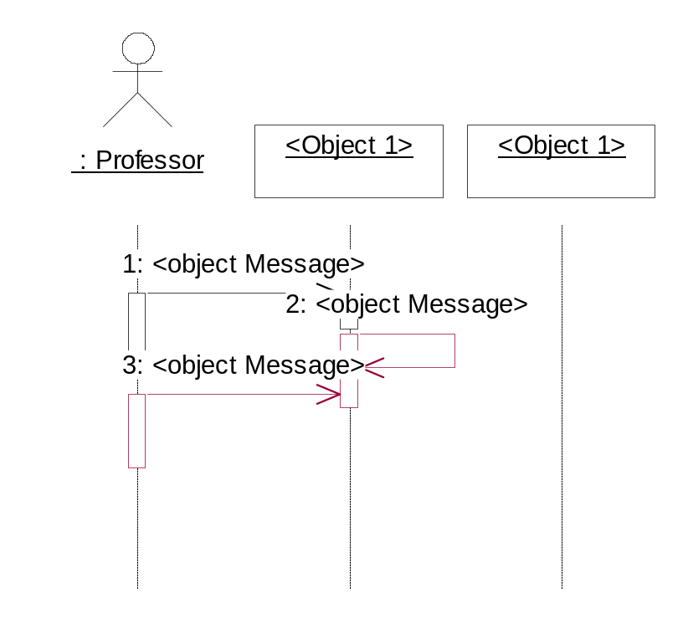

<<Insert sequence diagrams here. Please note that you could insert the diagrams here directly OR provide reference to the file, which contains this.
The actual insertion into the document can be deferred at the time of delivery of the document to the client.
But is necessary to specify the version number of every such document referenced here and every change in the referenced document should be tracked as part of the Change Log to the Design Document>>

Derived Requirements
<Description that collects all requirements, such as non-functional requirements, on the use-case realizations that are not considered in the design model, but that need to be taken care of during implementation>

User Registration

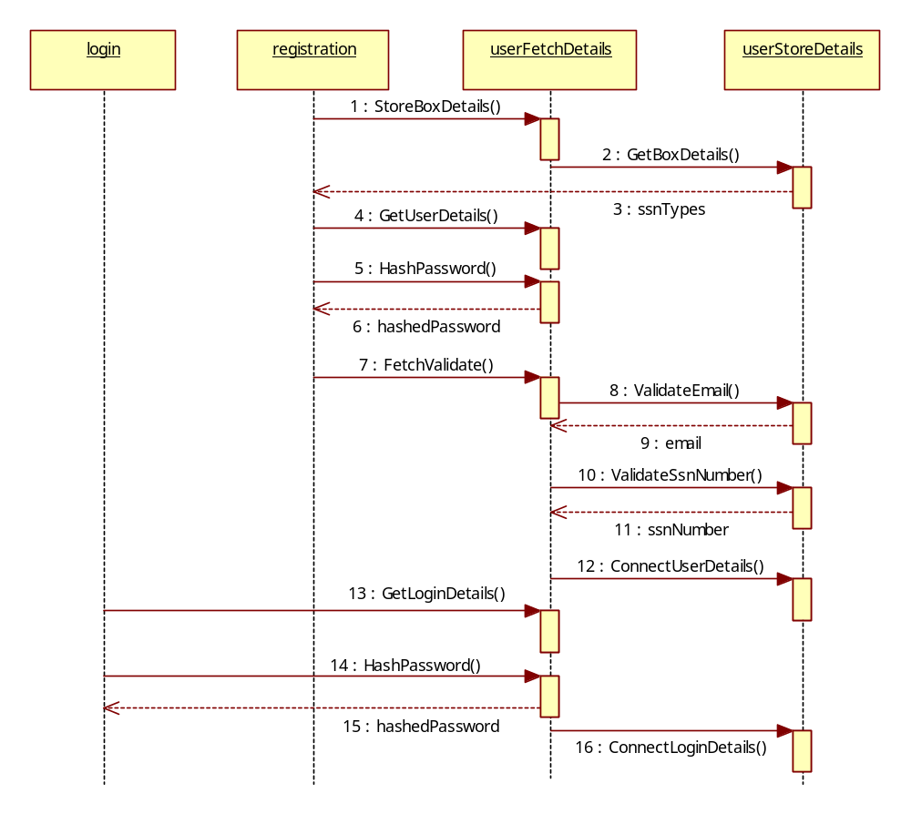

Search Flight
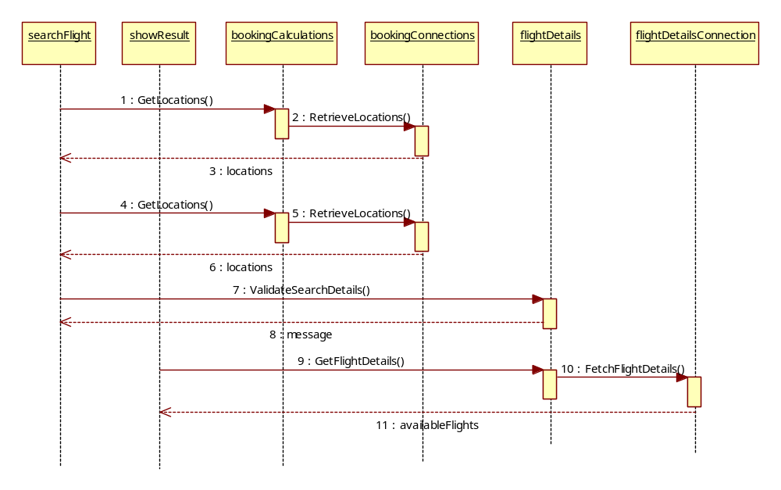

Booking Flight
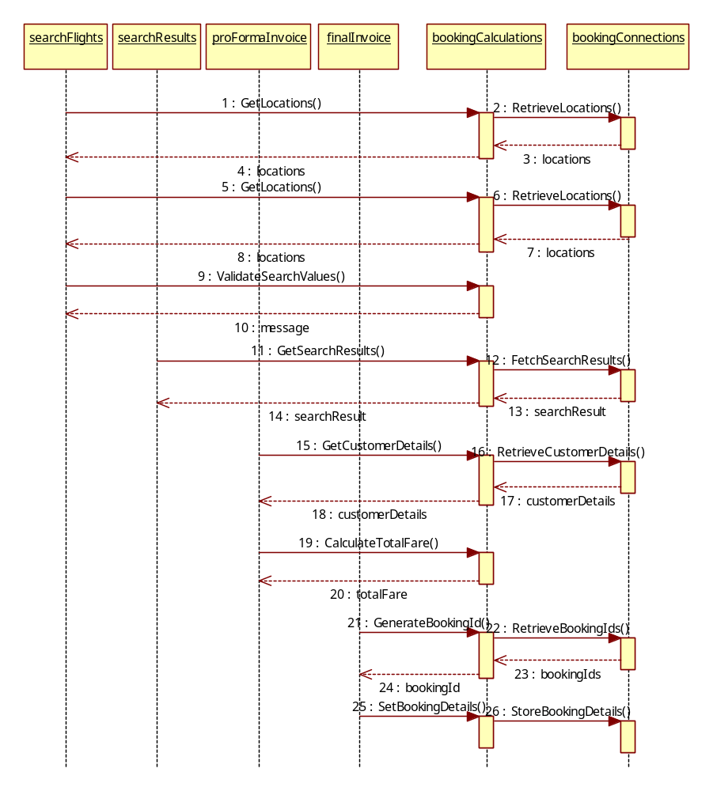

Cancellation
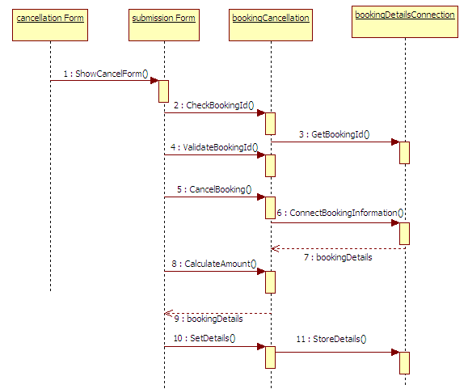

Edit Profile
Login
User Option
Edit / Update
Get Email, Password and validation
Edit field
Data update

Set Email, Password

Package & Sub-system Design
<The purpose of this section is to explain the design over view of package or the sub system. The Design Model can be split into smaller units to make it easier to understand. By grouping Design Model elements into packages and subsystems, then showing how those groupings relate to one another, it is easier to understand the overall structure of the model>

Package Design
<Packages are general-purpose hierarchical organizational units (units as in classes, relationships etc.). Such units are not contained in some other element. Elements such as attributes, operations, states, lifelines, and other messages are contained in other elements and do not appear as direct contents of packages.
A package may contain other packages. There is a root package that indirectly contains the entire model of a system. There are several ways to organize packages: - By view, BY functionality, or other relevant basis.
- If the packages are well chosen they can reflect the high-level architecture of the system.
- Identification of packages so that teams can work without interfering with each other.
- Delineating source code into logical partitions to enhance maintainability
- Implementing effective Configuration Management
- Access Control
Constructing libraries etc.>

Packages 1…N
<Packages may be depicted here>
Attribute Name | Brief Description of Attribute
Name | The name of the package.
Brief Description | A brief description of the role and purpose, or the "theme" of the package.
Classes | The classes directly contained in the package.
Relationships | The relationships directly contained in the package.
Use-Case Realizations | The use-case realizations directly contained in the package.
Diagrams | The diagrams directly contained in the package.
Design Packages | The packages directly contained in the package.
Import Dependencies | The import dependencies from the package to other packages.

Sub-system Design
<A subsystem is a physical unit of implementation with well-define interfaces that is intended to be used as replaceable part of the system. Each sub system embodies the implementation of certain classes. Well-defined subsystems do not depend directly on other sub systems but on interfaces that sub system support.
Note: If this already addressed as part of architecture, this may be skipped here and referenced here>
Property Name | Brief Description
Name | The name of the subsystem
Brief Description | The short description of the role and purpose, or the "theme" of the subsystem.
Interfaces | Associations to realized interfaces
Contents | Aggregation associations to contained model elements
Dependencies | Dependency associations to interfaces, packages, or subsystems on which the subsystem depends
Diagrams | Any diagrams local to the subsystem, such as class diagrams or statechart diagrams.

Generic Components Design
<Generic design may include the following:
- Framework classes
- Audit Trial Classes
- Authority Checks
- Alarms/Error/Notification Requirements
- Operational Sequence Check
- Device Check
- Electronic Signatures
- Process Control Parameters
- Authorization
- Record Access
- Record retention & recovery requiremen>

A component is a physical unit of implementation with well-defined interfaces that is intended to be used as replaceable part of the system. Each component embodies the implementation of certain classes. Well-defined components do not depend directly on other components but on interfaces that components support>

Object Model

System Object Model

Registration

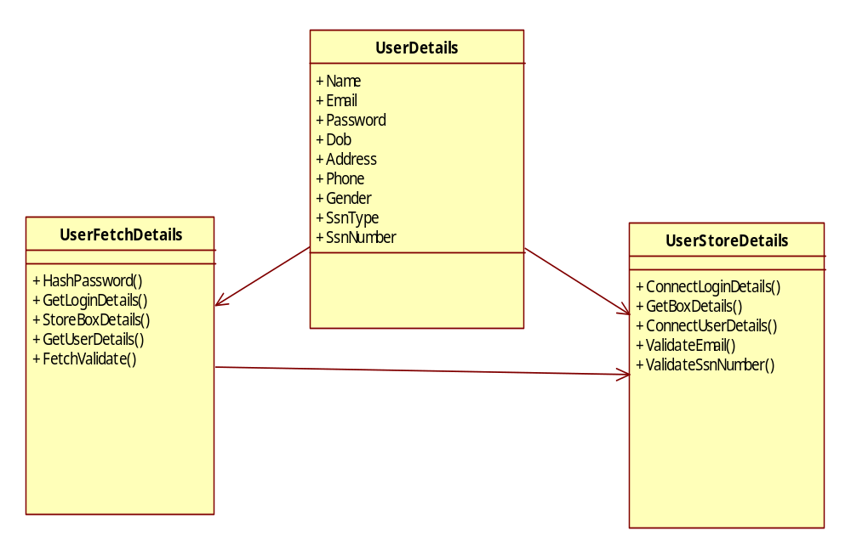
Registration

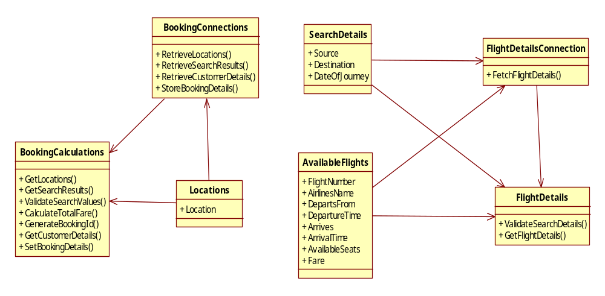
Booking

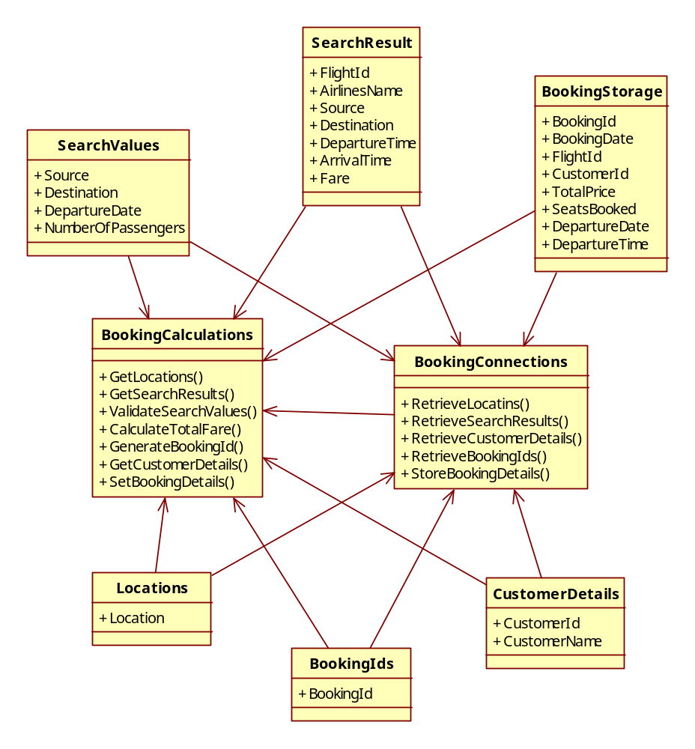
Cancellation

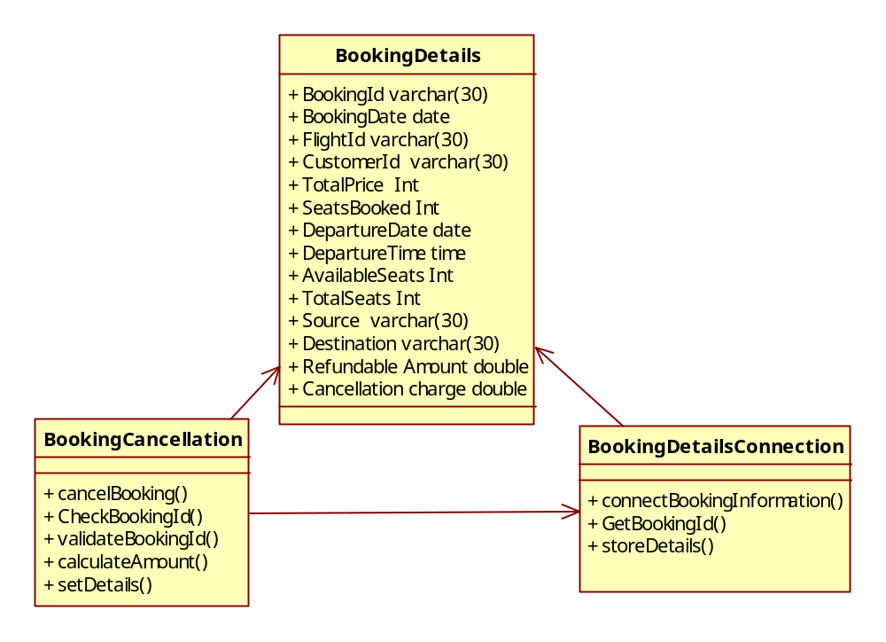
Edit Profile

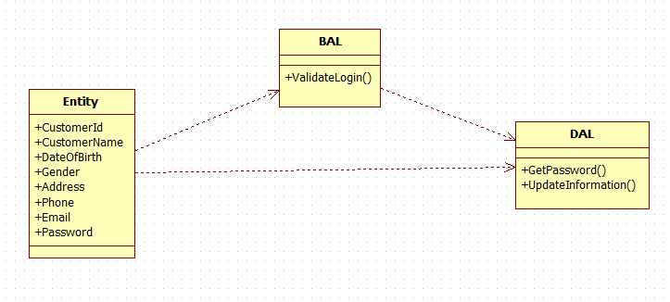

Object Descriptions
<In this section you would describe in detail each object, its attributes and its methods. You should logically group objects together. For example, you may use your architecture diagrams to group objects within a sub-system together. These may be directly referenced from Object Modeling tools if used in the project and maintained at the level given below >

Object <Name>
- Purpose:
- Constraints: None
- Persistent: No (created at system initialization from other available data)

Attribute Descriptions
- Attribute:
Type:
Description:
Constraints:
- Another attribute…

Method Descriptions
- Method:
Return Type: Boolean
Parameters:
Return value: success or failure
Pre-condition:
Post-condition:
2. Attributes read/used:
3. Methods called:
4. Processing logic:

Object Name | Object Description
userDetails | Gets the user details from the user
userFetchDetails | Used to call the method in business logic layer
userStoreDetails | Used to call the method in data access layer

Object Name | Object Description
searchFlight | Gets the flight details from the user
showResult | Displays the search results to the user
flightDetails | Used to call the method in business logic layer
flightDetailsConnection | Used to call the method in data access layer
Object Name | Object Description
searchFlights | Gets the search criteria from the user
searchResults | Displays the search results to the user and allows the user to select a particular flight
proFormaInvoice | Displays the proforma invoice to the user with booking date and total price
FinalInvoice | Displays the final invoice to the user with the generated booking id
bookingCalculations | Used to call the methods in business logic layer
bookingConnection | Used to call the methods in data access layer
Object Name | Object Description
bookingDetails | Get the booking details from the user
bookingCancellation | Used to call the method in business logic layer
bookingDetailsConnection | Used to call the method in data access layer

Database Design

Data Model
<Map persistent design classes into the data model>

Identification of Tables

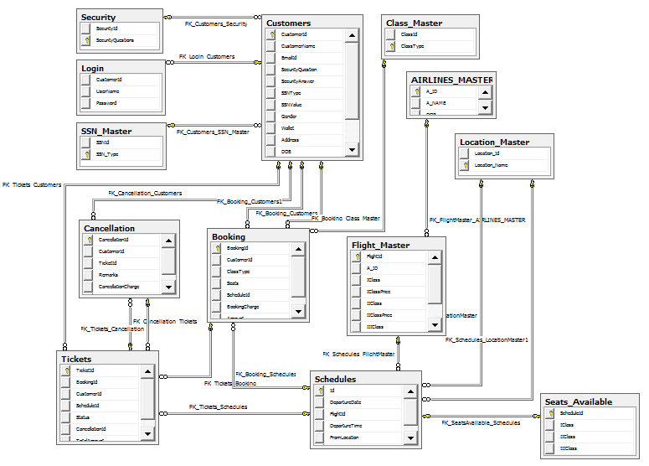

Table Details
UserDetails
Column Name | Data Type | Length | Nulls
CustomeId | Numeric | 10 | No
CustomerName | Varchar | 30 | No
Email | Varchar | 30 | No
Password | Varchar | 150 | No
Dob | Varchar | 30 | No
Address | Varchar | 50 | No
Phone | Numeric | 10 | No
Gender | Varchar | 6 | No
SsnType | Varchar | 30 | No
SsnNumber | Varchar | 30 | No
SSNMaster
Ssntype
Pan card
Voter-id card
Driving licence
passport

AirlinesMaster
Column Name | Data Type | Length | Nulls
AirlinesId | varchar | 30 | N
AirlinesName | varchar | 30 | N

SeatsAvailable
Column Name | Data Type | Length | Nulls
FlightId | varchar | 30 | N
AvailableSeats | Int |  | N
DepartureDate | Date |  | N

FlightMaster
Column Name | Data Type | Length | Nulls
FlightId | varchar | 30 | N
AirlinesId | varchar | 30 | N
TotalSeats | int |  | N
Source | varchar | 30 | N
Destination | varchar | 30 | N
DepartureTime | time | 7 | N
ArrivalTime | time | 7 | N
Fare | int |  | N

BookingDetails
Column Name | Data Type | Length | Nulls
BookingId | varchar | 30 | N
BookingDate | Date |  | N
FlightId | varchar | 30 | N
CustomerId | varchar | 30 | N
TotalPrice | int |  | N
SeatsBooked | int |  | N
DepartureDate | date |  | N
DepartureTime | time | 7 | N

AirlinesMaster
Column Name | Data Type | Length | Nulls
AirlinesId | varchar | 30 | N
AirlinesName | varchar | 30 | N

LocationMaster
Column Name | Data Type | Length | Nulls
LocationId | int |  | N
LocationName | varchar | 30 | N

Referential Integrity Constraints
<Specify all Primary Key, Foreign key, Triggers and other such constraints that enforce data integrity as well as referential integrity constraints>

Computations/processing in Database
Stored Procedure Names | Fields Used | Description
GetLogin | - Email  - password | Used to check whether the password and email id matches with the credentials present in the database.
StoreRegistration | - customerid  - name  - email  - password  - dob  - address  - phone  - gender  - ssntype  - ssnnumber | Used to insert the data entered by the user during registration process into the database.
GetSsnTable | - ssntype | Used to fetch the SSN type details from the database to the presentation layer.
GetCustomerId | - customerid | Used to get the last customerid generated.
EmailValidate | - email | Used to get the email id from the database matching with the user entered email.
SsnNumberValidate | - ssnnumber | Used to get the ssn number from the database matching with the user entered ssn number.

8.1.4 Object Model
Object Name | Object Description
userDetails | Gets the user details from the user
userFetchDetails | Used to call the method in business logic layer
userStoreDetails | Used to call the method in data access layer

Object Name | Object Description
bookingDetails | Get the booking details from the user
bookingCancellation | Used to call the method in business logic layer
bookingDetailsConnection | Used to call the method in data access layer

Object Name | Object Description
GetPassword | Get the password from the database
ValidatePassword | Checks the given password with the database password.
UpdateCustomerDetails | Updates the customer details to the database

searchFlight | Gets the flight details from the user
showResult | Displays the search results to the user
flightDetails | Used to call the method in business logic layer
flightDetailsConnection | Used to call the method in data access layer

Object Name | Object Description
bookingDetails | Get the booking details from the user
bookingCancellation | Used to call the method in business logic layer
bookingDetailsConnection | Used to call the method in data access layer

Object Name | Object Description
searchFlights | Gets the search criteria from the user
searchResults | Displays the search results to the user and allows the user to select a particular flight
proFormaInvoice | Displays the proforma invoice to the user with booking date and total price
FinalInvoice | Displays the final invoice to the user with the generated booking id
bookingCalculations | Used to call the methods in business logic layer
bookingConnection | Used to call the methods in data access layer

Access Control Details

<Administrative details which are not specific to any program of the application, but connected to database/file system.
- Administration
- Security and access rights
- Record locking, etc>.

Storage Characteristics
<Storage characteristics needs to be mentioned here and should include current as well as estimates for expansion in the future. This include some of the following:
- Disk page density
- Disk page location
- Disk space allocation etc

Database Performance Improvement Measures
- Usage of Indexes to improve query performance (Keep in mind that indexes have a hidden cost: indexes cost time to update and occupy disk space. Be sure you get value from using them)
- Right choice of indexing strategy
- Query optimization
- Use of Prepared Statements and parameter binding
<INSERT YOUR DATA MODEL HERE>

References

Change Log
Please note that this table needs to be maintained even if a Configuration Management tool is used.
Version Number | Changes made
V1.0 | <First version>
V1.1 | <If the change details are not explicitly documented in the table below, reference should be provided here>
V1.1 | Page no | Changed by | Effective date | Changes effected
V1.2 | <If the change details are not explicitly documented in the table below, reference should be provided here>
V1.2 | Page no | Changed by | Effective date | Changes effected

